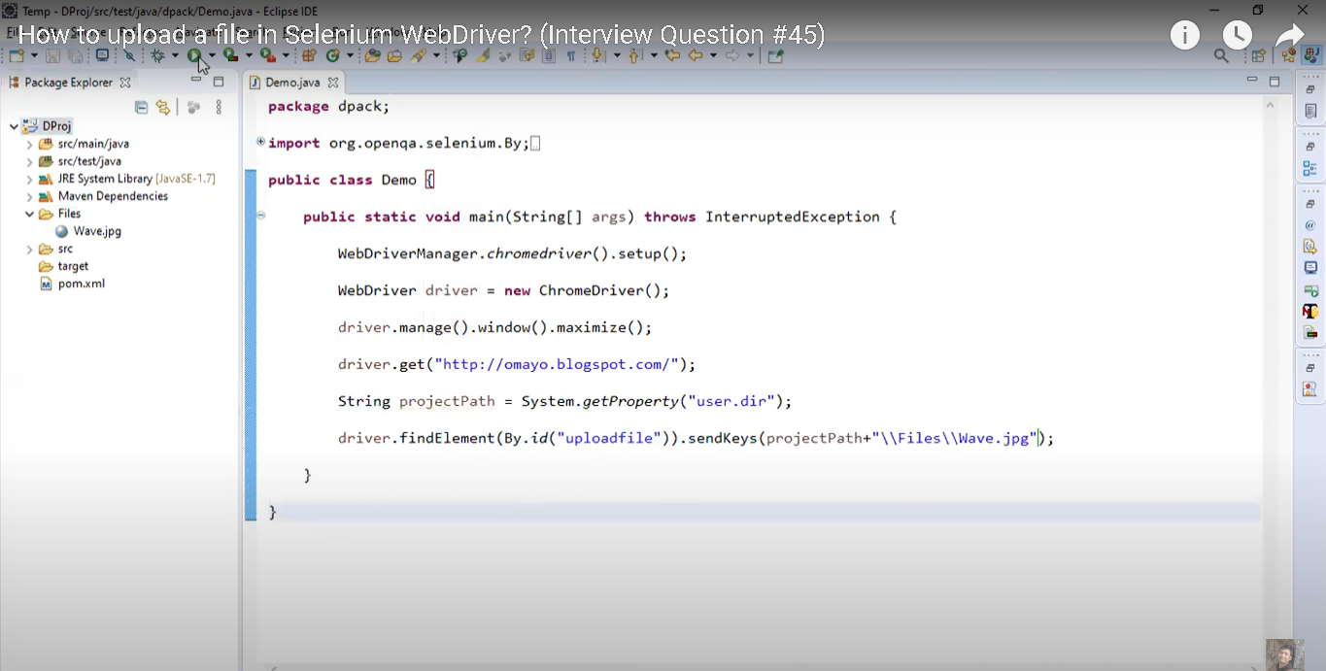

<https://www.youtube.com/watch?v=Uraakjx1TYM>

**How to upload a file in Selenium WebDriver? (Interview Question #45)**